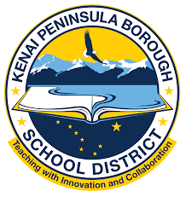 | Kenai Peninsula Borough School District  2024 Legislative Priorities
 | Achieving the KPBSD Board of Education’s Goals and the District Strategic Plan Priorities will require close collaboration and partnership with the Alaska State Legislature.
 | Support student success through programs and rigorous standards that ensure preparation for success in life.  - Prioritize career and technical opportunities for all students.  - Focus on improving the number of students at or above grade level in Literacy and English Language Arts using evidence-based practices.  - Increase the number of students at or above grade level proficiency in Math using targeted core instruction.  - Support the development of student citizenship, readiness for the workforce, and endeavors beyond graduation.  - Support Alaska Reads Act Implementation  - Increase communication pathways
 | Provide fair, predictable, and proactive funding.  - Focus on retention and recruitment of high-quality educators by investing in defined benefits.  - Create innovative pathways to growing our own teachers and staff.  - Adjust the Base Student Allocation (BSA) and develop mechanisms to compensate for inflation.  - Provide transportation funding based on actual expenditures.  - Explore affordable health care for employees.  - Funding deferred maintenance costs, prevent/oppose cost shifting
 | Ensure safe schools and support student well-being by creating positive school climates and targeting student social, emotional, and wellness development.  - Foster family and community engagement.  - Support extracurricular activities.  - Focus on approaches that target student health: physical, social, mental, and emotional.  - Provide training in trauma informed practices.  - Improve school safety and building security.
Let’s start a conversation.

