Written Instructional Program
Provide evidence of a written instructional program that addresses state content standards under 4 AAC 04 and aligns with the content on the statewide assessment system under 4 AAC 06.710-4 AAC 06.790 marked as Appendix F. 4 AAC 33.110(a)(6)

Instructional Program Overview
Soldotna Elementary Charter School's will provide a coordinated K–6 instructional program that combines explicit core academic instruction, specialist-supported STREAM learning, and social-emotional skill development. Its defining features are the planned connection among classroom learning, dedicated Science, Music, and Physical Education instruction, teacher collaboration, and inclusive participation. The school will implement the curriculum and required assessments adopted by KPBSD, address Alaska State Content and Performance Standards under 4 AAC 04 and align with the statewide assessment system under 4 AAC 06.710–4 AAC 06.790.
The KPBSD curriculum will provide the academic foundation. The school's instructional adaptations will connect Science, Technology, Reading, Engineering, Arts, and Mathematics (STREAM) through investigations and design experiences linked to grade-level learning. Students will use reading, writing, mathematics, evidence, and creative expressions to explain ideas and solve problems. Experiential and place-based learning will connect appropriate units to Soldotna and the Kenai Peninsula.

KPBSD's current curriculum framework includes District curriculum maps for language arts, mathematics, science, and social studies, together with District-adopted foundational and supplemental instructional resources. KPBSD currently identifies Amplify CKLA as its elementary foundational ELA resource, iReady Math as the K–5 foundational mathematics resource, Mystery Science as a K–5 foundational science resource, and Discovery Education as an elementary social studies resource. Soldotna Elementary Charter School will use these or their KPBSD-adopted successors in effect when the school opens.
KPBSD establishes what students are expected to learn. The Soldotna Elementary Charter School STREAM model provides additional opportunities for students to connect, apply, and demonstrate that learning. STREAM and SEL integration will supplement, rather than replace, explicit instruction in foundational literacy, mathematics, science, social studies, and other required academic content. The program will also recognize KPBSD's Career and Technical Education (CTE) framework through early career awareness, applied learning, and development of foundational skills that support later participation in district CTE pathways.
The preliminary staffing model also includes dedicated specialized teachers in Science, Music, and Physical Education. These specialists will provide sequential instruction in their disciplines and coordinate with classroom teachers to reinforce grade-level priorities. The school will use its schedule, collaborative planning, and annual program review to sustain these connections across classrooms and grades. Staffing will be finalized through the approved annual budget.

Defining Features of the Instructional Model
The school's distinction lies in how these elements operate together as a consistent program. Dedicated science instruction will anchor investigations and engineering experiences; classroom teachers will connect those experiences to literacy and mathematics; Music and Physical Education will provide discipline-specific learning and relevant opportunities for creative expression, teamwork, and self-management. Teachers will plan these connections deliberately and assess both academic understanding and application.
The program will establish a common K–6 progression, scheduled specialist instruction, explicit SEL instruction reinforced during academic work, and documented interdisciplinary experiences. Each grade level will plan and deliver at least one standards-aligned STREAM experience per quarter. Experiences may be short investigations or longer projects according to students' age and the curriculum; they will connect at least two disciplines and produce evidence of student learning.
Inclusive participation is part of the instructional design. Classroom teachers, specialists, and special education staff will coordinate accommodations, accessible materials, scaffolds, and enrichment so students with different strengths and support needs can contribute to shared learning experiences.
The proposal's neighborhood access, transportation, and meal plans support participation by the existing school community, as described in the application’s admissions and operations sections.

Standards Alignment and Curriculum Development
Soldotna Elementary Charter School's instructional program will align with the Alaska standards in effect for each content area, including English Language Arts, Mathematics, Science, Social Studies, Arts, Computer Science and Digital Literacy, Health and Physical Education, and other applicable standards. Alaska currently maintains 2012 ELA and mathematics standards, 2019 science standards, 2024 social studies standards, 2015 arts standards, and 2019 computer science and digital literacy standards.
Teachers will use KPBSD curriculum maps, District-adopted instructional resources, and District assessments as the basis for planning. Because KPBSD curriculum and instructional resources will continue to evolve, Soldotna Elementary Charter School will not be tied to a particular commercial program named in the original charter. The school will implement the current KPBSD curriculum and subsequent District revisions while maintaining the instructional philosophy described in this charter.
The APC, administrator, and instructional staff will periodically review implementation of the instructional program. Supplemental resources or instructional approaches may be used to support STREAM integration, project-based learning, enrichment, intervention, or student needs, provided that those resources remain consistent with Alaska standards, KPBSD requirements, and the school's charter.

Soldotna Elementary Charter School Adaptations
Soldotna Elementary Charter School's will build upon the KPBSD curriculum through intentional instructional adaptations. Grade-level teams will identify shared questions, investigations, and design tasks that connect academic objectives and help students apply what they learn. The annual curriculum map will show these experiences alongside required core instruction.
Within planned STREAM experiences, students will investigate a question or address a problem, gather information, use evidence, create or test a response, and communicate what they learned. A science investigation may require informational reading, mathematical measurement and data analysis, engineering design, technology use, written explanation, and a visual representation. The disciplines included will depend on the learning objectives.

Teachers will select interdisciplinary connections that deepen the underlying academic objectives. Every STREAM experience will identify the standards addressed, the participating disciplines, the roles of classroom and specialist teachers, the student product or demonstration, and the assessment method. Lessons requiring focused instruction will retain that focus; an experience need not include every STREAM discipline.
Social-emotional skills will be taught explicitly and practiced during instruction and school routines. Teachers will identify a relevant skill for each planned STREAM experience, such as listening to a partner, sharing responsibility, managing frustration, responding to feedback, or resolving a disagreement. Students will practice the skill during the task and reflect on its effect on their work.

Alaska DEED guidance specifically recognizes that social-emotional skills can be infused into academic content and identifies practices such as establishing group agreements, teaching students to listen, asking effective questions, and explicitly developing self-regulation, relationship, decision-making, and self-awareness skills. Soldotna Elementary Charter School will use this type of embedded approach rather than relying solely on a stand-alone SEL class or program.
Soldotna Elementary Charter School is committed to providing meaningful SEL support throughout the school. Classroom teachers and staff will share responsibility for creating consistent schoolwide practices, while counseling or other dedicated student-support resources may augment those practices as staffing and funding permit.

Specialized Instruction in Science, Music, and Physical Education
Dedicated specialized instruction is a central element of the proposed program. The school plans three certificated specialized-teacher positions: one focused on Science, one on Music, and one on Physical Education. The Science teacher will provide hands-on science and engineering instruction across K–6, coordinate the progression of investigations and safe material use, and work with classroom teachers on connections to reading, writing, and mathematics. The Music teacher will provide sequential music instruction and develop relevant connections to pattern, expression, and communication. The Physical Education teacher will provide sequential movement and health-related learning while reinforcing cooperation, goal setting, and self-management.
The annual master schedule will identify recurring specialist periods for every grade, the frequency and duration of instruction, and dedicated opportunities for weekly grade-level or team collaboration. Specialist rotations will be used to support common planning where feasible and consistent with KPBSD requirements and negotiated agreements. Specialists will participate in coordinated planning so their work supports a coherent instructional sequence. The administrator will review the schedule and staffing plan annually with the APC to maintain these priorities within available resources.

English Language Arts and Reading
KPBSD's elementary English Language Arts curriculum addresses reading literature, informational text, foundational reading skills, writing, speaking and listening, and language. KPBSD has also adopted Amplify CKLA as its current elementary foundational ELA program (K-5) and Into Literature Scope and Sequence Documents for Grades 6+.
Soldotna Elementary Charter School will implement the KPBSD ELA curriculum and comply with applicable Alaska literacy and reading requirements. In the primary grades, particular emphasis will be placed on explicit foundational reading instruction, including phonological and phonemic awareness, phonics, decoding, fluency, vocabulary, oral language, and comprehension. STREAM activities will not replace systematic literacy instruction.
Soldotna Elementary Charter School adaptations will provide additional opportunities for students to use literacy as a tool for learning across disciplines. Figure F-1 below describes what students in the following grades may experience:
Figure F-1: ELA Examples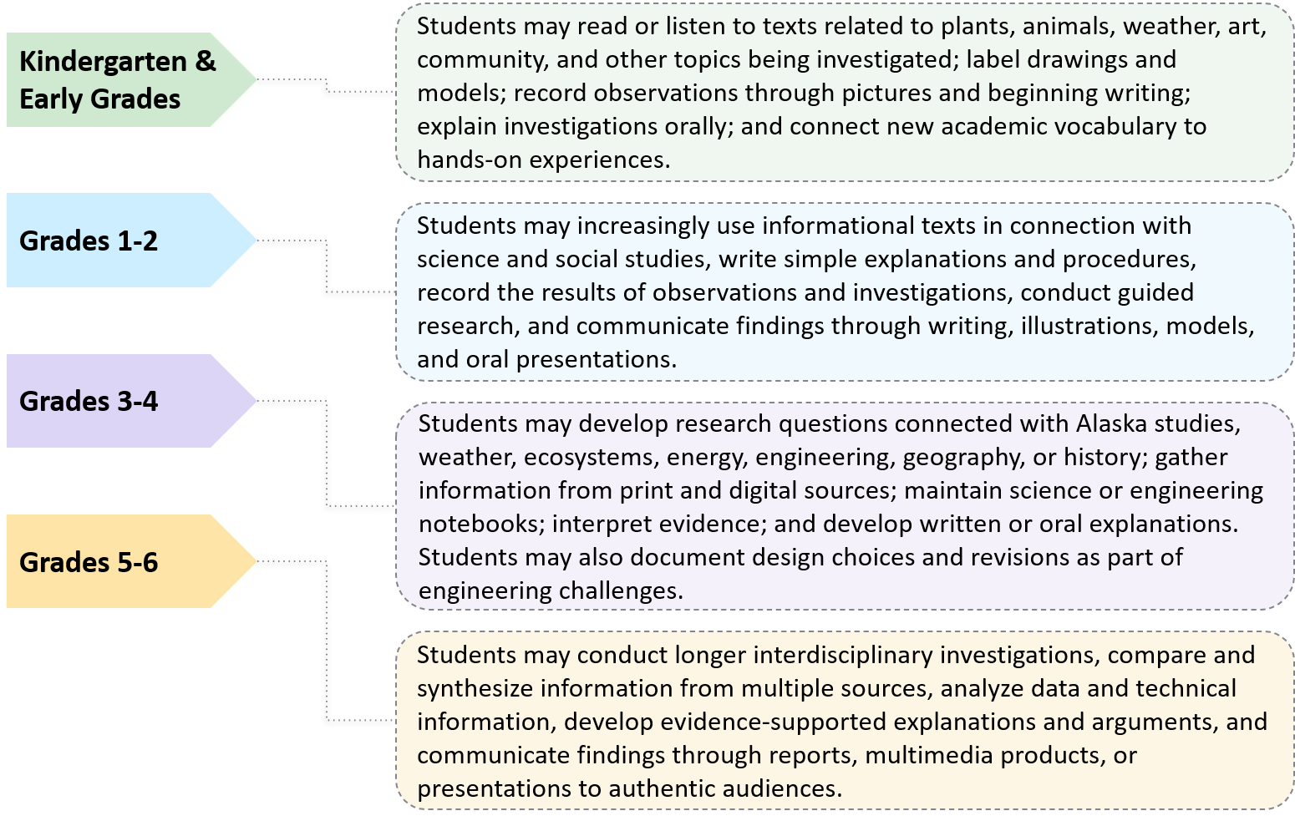
This approach is consistent with established interdisciplinary models in which reading and writing are reinforced throughout science and project-based instruction. Anchorage STrEaM Academy, for example, describes all teachers as teachers of reading, explicitly integrates academic vocabulary and reading strategies across subjects, and incorporates writing and research across disciplines.
SEL may also be reinforced naturally through ELA instruction. Literature provides opportunities for students to discuss perspective, motivation, relationships, decision-making, and responses to challenges. Speaking and listening activities provide structured practice in respectful discussion, listening to differing perspectives, asking questions, giving feedback, and communicating effectively with peers.

Mathematics
Soldotna Elementary Charter School will follow KPBSD's mathematics curriculum and use the District's adopted mathematics resources. KPBSD currently identifies Ready Math/iReady as the K–5 foundational mathematics program and maintains grade-specific curriculum maps for kindergarten through grade 5 and curriculum materials for grade 6.
Mathematics instruction will emphasize both conceptual understanding and procedural fluency. Students will receive explicit instruction, guided and independent practice, and opportunities to develop mathematical reasoning, communicate mathematical thinking, solve problems, and apply mathematics in increasingly complex situations.
Soldotna Elementary Charter School adaptations will provide additional opportunities to apply mathematics within authentic contexts. In the primary grades, students may count and classify natural objects, identify patterns, compare measurements, collect simple data, use geometric shapes in construction activities, or measure plant growth and weather observations.
In the intermediate grades, students may apply multiplication and division to collected data, use fractions within measurement activities, calculate area and perimeter for designs or models, create graphs from science investigations, and use mathematics to compare alternative solutions to an engineering problem.
Upper-elementary students may use fractions, decimals, ratios, geometry, statistics, surface area, volume, and other grade-level concepts within science, environmental, technology, and design investigations. Students might analyze environmental data, construct scale models, calculate quantities for a design, compare rates, or use statistics to interpret the results of an investigation.
STREAM mathematics applications will provide authentic opportunities to reinforce KPBSD mathematics instruction but will not substitute for systematic instruction and practice in grade-level mathematical concepts.
Mathematical problem solving also provides opportunities to reinforce SEL-related skills such as perseverance, productive response to mistakes, explaining one's thinking, listening to alternative approaches, and working collaboratively toward solutions.

Science and Engineering
Science and engineering will provide one of the principal anchors for Soldotna Elementary Charter School STREAM learning. Students will use observation, questions, investigations, data, and evidence to understand natural systems, and use age-appropriate design processes to develop and improve solutions. Teachers will connect these experiences to the KPBSD science curriculum and relevant literacy and mathematics objectives.
The preliminary staffing plan includes a dedicated Science teacher serving students across grades K–6. Every class will participate in a scheduled science rotation.
Classroom teachers and the Science teacher will coordinate preparation, investigation, and follow-up: classroom learning will build background knowledge and academic vocabulary; specialist instruction will support inquiry, equipment use, and design; and follow-up work will develop data analysis and evidence-based communication. The annual master schedule will specify the rotation’s frequency and duration.
.
Figure F-2 below highlights KPBSD's published science curriculum progresses across grades K-6.
Figure F-2: KPBSD Science Curriculum Progression
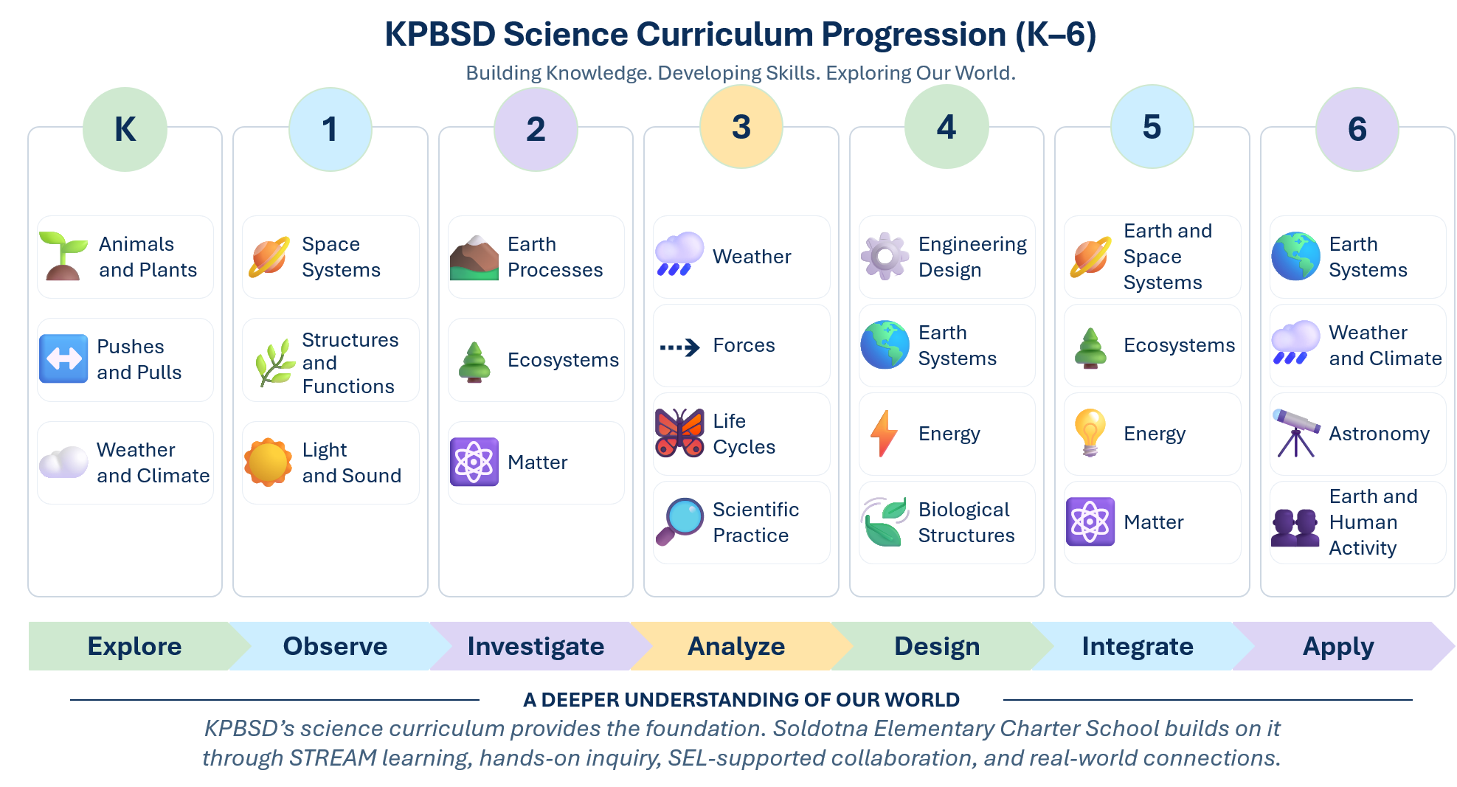

Social Studies and Community Connections
Soldotna Elementary Charter School adaptations will emphasize opportunities to connect these concepts to students' community and region. Younger students may map the classroom, school, neighborhood, or community; learn about local occupations and institutions; develop timelines; compare how people lived or worked in different periods; and use stories, art, photographs, maps, and interviews to investigate community life.
Grade 2 students may investigate Soldotna and the Kenai Peninsula, including community services, geography, natural resources, local businesses, and community history. Grade 3 Alaska Studies may provide opportunities for research and projects involving Alaska geography, history, cultures, resources, government, or local and regional connections. Instruction concerning Alaska Native cultures will be developed using appropriate KPBSD resources and, where possible, authentic community or cultural resources.
Students in grades 4 through 6 may increasingly use primary sources, maps, geographic information, historical documents, research, quantitative data, and technology to investigate regions, historical change, resource use, government, economics, and relationships between people and the environment.
The 2024 Alaska Social Studies Standards place explicit emphasis on inquiry as well as disciplinary content. Soldotna Elementary Charter School’s use of research, evidence, questioning, geographic analysis, and community-connected projects will complement these expectations while remaining anchored in KPBSD curriculum.
Social studies also offers natural opportunities to reinforce SEL through discussion of perspective, culture, citizenship, cooperation, community responsibility, respectful disagreement, and decision-making.

Arts and Creative Expression
Soldotna Elementary Charter School will implement the KPBSD fine arts curriculum and applicable Alaska Arts Standards. KPBSD's existing fine arts framework includes K–6 curriculum resources for music, visual arts, drama, and dance, including grade-level visual arts guidance, K–6 music standards organized around performing, responding, creating, and concepts and skills, and developmentally sequenced drama and dance resources. KPBSD also provides dedicated arts-integration resources for teachers.
Soldotna Elementary Charter School will provide arts instruction consistent with Alaska standards and KPBSD curriculum. The arts component of STREAM reflects the school's belief that creativity, design, communication, and artistic expression support a well-rounded elementary education.
Soldotna Elementary Charter School adaptations may integrate visual art, music, performance, design, photography, multimedia, or other forms of creative expression into interdisciplinary learning when appropriate. Students might create scientific illustrations, maps, models, displays, performances, multimedia presentations, or artistic representations of concepts being studied.
Arts integration will complement rather than replace dedicated arts instruction. The preliminary staffing model includes a dedicated Music teacher who will provide sequential K–6 music instruction aligned with KPBSD curriculum and Alaska Arts Standards. Visual art, drama, dance, design, and other creative expression may also be integrated into classroom and STREAM learning, with additional specialist support considered as staffing and resources permit.
Creative activities also offer opportunities for students to develop confidence, communicate ideas in different ways, give and receive constructive feedback, revise work, and appreciate different perspectives.

Health and Physical Education
The preliminary staffing model includes a dedicated Physical Education teacher serving grades K–6. Physical education will be aligned with applicable Alaska standards and KPBSD expectations and will provide regular opportunities for students to develop movement skills, physical fitness, teamwork, healthy habits, and lifelong wellness practices.
Physical Education also provides natural opportunities to reinforce the school’s SEL priorities through cooperation, self-management, perseverance, goal setting, responsible decision-making, and constructive participation with peers. Classroom teachers may reinforce health and wellness concepts across the school day, while the specialized Physical Education teacher provides dedicated instruction and progression of skills.

Technology and Digital Literacy
Soldotna Elementary Charter School will implement KPBSD educational technology expectations and applicable Alaska Computer Science and Digital Literacy Standards. KPBSD currently maintains educational technology standards, performance indicators, and a technology-skills continuum.
Technology will be treated as a purposeful tool for learning rather than an end in itself. Depending on grade level, students may use digital tools to research, collect or analyze data, create graphs, communicate findings, produce multimedia work, code, model systems, document projects, or collaborate.
In the primary grades, technology use will be developmentally appropriate and balanced with direct teacher instruction, books, handwriting, manipulatives, physical movement, play, outdoor experiences, and hands-on exploration. Technology use will become progressively more independent as students develop the ability to research, evaluate information, create digital products, and use technology to solve problems.
Digital citizenship, responsible technology use, communication, and decision-making also provide opportunities for integration with SEL and health instruction.

Career and Technical Education Connections
Soldotna Elementary Charter School will recognize KPBSD's Career and Technical Education (CTE) framework and use developmentally appropriate STREAM experiences to build early career awareness and foundational applied skills. KPBSD's published CTE philosophy emphasizes academic knowledge, higher-order reasoning, problem solving, work attitudes, employability skills, and safety. The school will introduce these foundations within the regular K–6 instructional program and connect classroom learning to the broader district system of career clusters and pathways.
Students will practice following directions, measuring accurately, using age-appropriate tools and materials safely, organizing tasks, communicating findings, and completing work with a team. Teachers will connect these skills to occupations and community needs through reading, investigations, design projects, and, where feasible, visits or presentations by community members. Projects may introduce fields such as natural resources, construction and design, information technology, health, and business. Career exploration will remain broad so students can discover interests without being directed toward a particular occupation.
For example, a plant-growing STREAM project may introduce agriculture and natural resource careers. Students can investigate growing conditions, measure and graph growth, design or improve a planter, calculate material quantities or simple costs, and explain their results. These experiences connect literacy, mathematics, science, technology, and design with practical work while providing opportunities to practice planning, collaboration, and responsibility.
Teachers will coordinate with KPBSD's College and Career staff, as appropriate, to identify current pathway connections and suitable resources. District CTE kits may be considered where available and appropriate for elementary students. Grade 6 students may use district career-exploration resources, including Naviance or its successor, as available and consistent with district guidance. These elementary experiences will prepare students to explore later middle and high school CTE opportunities; occupational certifications and secondary CTE course requirements apply at those later levels.

Social-Emotional Learning and Student Development
Soldotna Elementary Charter School views social-emotional development as supportive of, and interconnected with, academic learning. Students who can communicate effectively, regulate behavior, work collaboratively, persist through challenges, and seek help when necessary are better positioned to engage successfully in rigorous academic work.
Teachers will provide explicit SEL instruction each week during the instructional sequence and reinforce the current skill through classroom routines, discussions, partner work, specialist instruction, and project reflection several times during the week. Common language and routines will support consistent expectations across settings. Instruction will address self-awareness, emotion management, communication, cooperation, problem solving, responsible decision-making, and help-seeking in developmentally appropriate ways.

The school will explore the use of Second Step Elementary Digital Program as a structured framework for explicit SEL instruction, subject to access to the program and coordination with KPBSD. The program addresses growth mindset and goal setting, emotion management, empathy and kindness, and problem solving. Teachers would generally teach one 15- to 30-minute core lesson each week during the program sequence, then revisit the skill through brief classroom meetings, discussion prompts, partner work, or reflection a few times during the week. The digital materials support teacher-led instruction and do not require students to spend those lessons working independently on screens. Teachers will connect the current SEL skill to authentic classroom situations, such as managing frustration during a design challenge, listening to a partner during an investigation, or resolving a disagreement about a group task.
Project-based STREAM instruction provides regular opportunities for students to practice these skills in authentic contexts. Students working collaboratively on an investigation or engineering problem must listen to others, divide responsibilities, communicate their reasoning, respond constructively when a solution does not work, negotiate different approaches, and revise their work.
Classroom teachers and specialists will used shared SEL language and prompt students to apply the current skill across settings. In a STREAM experience, students will reflect on both their academic learning and a relevant collaboration or self-management skill. Staff will review implementation and school-climate information to identify where additional modeling, practice, or support is needed.

Soldotna Elementary Charter School is committed to providing SEL support regardless of whether the school is able to staff a dedicated counseling position. If funding and staffing permit, a counselor or other student-support professional may provide additional direct services, targeted support, and staff training. However, responsibility for creating a supportive environment and reinforcing social-emotional skills will remain a schoolwide commitment rather than depending exclusively on one position.

Grade-Level Progression of the Soldotna Elementary Charter School Instructional Model
The Soldotna Elementary Charter School instructional model will become progressively more complex and student-directed as students advance through the grades. STREAM experiences will move from guided exploration in the primary grades toward increasingly independent investigation, interdisciplinary application, and problem solving in the upper grades. Social-emotional skills will develop alongside this progression, with increasing expectations for collaboration, perseverance, reflection, independence, and leadership.
Figure F-3: Grade-Level Progression
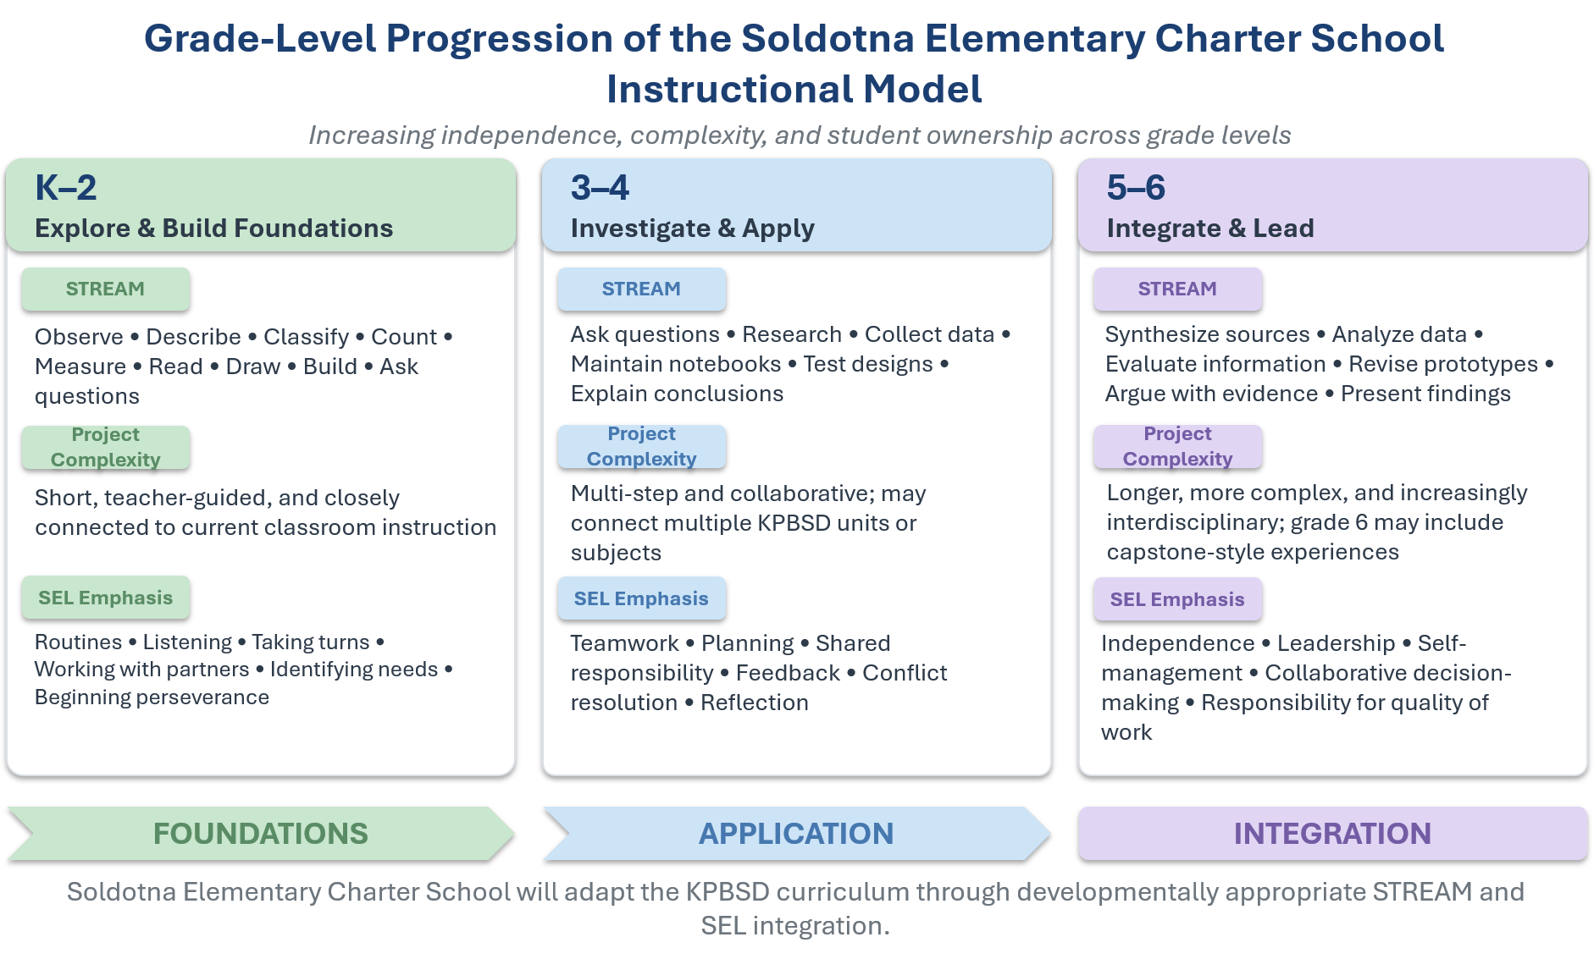
Kindergarten–Grade 2: Explore and Build Foundations: In the primary grades, STREAM learning will generally be highly teacher-guided, concrete, and closely connected to current classroom instruction. Students will observe, describe, classify, count, measure, read, draw, build, explore, ask questions, and communicate what they notice. Projects and investigations will typically be relatively short and structured, with an emphasis on developing curiosity and foundational academic skills.
SEL development will focus on skills that support successful classroom participation, including listening, taking turns, working with partners, following routines, communicating needs, and beginning to persist when a task is challenging.
Grades 3–4: Investigate and Apply: In grades 3 and 4, students will take greater responsibility for their learning. They will increasingly develop questions, gather information, collect and represent data, conduct multi-step investigations, maintain science or design notebooks, construct and test solutions, and communicate conclusions.
STREAM experiences may begin to connect multiple KPBSD subjects or units around a common question or problem. Students will have greater responsibility for planning portions of their work and explaining how evidence supports their conclusions.
SEL development will increasingly emphasize teamwork, planning, shared responsibility, constructive feedback, conflict resolution, independence, perseverance, and reflection.
Grades 5–6: Integrate and Lead: In grades 5 and 6, students will increasingly engage in longer, more complex, and interdisciplinary learning experiences. Students may formulate research questions, synthesize information from multiple sources, analyze data, evaluate information, design and revise prototypes, develop evidence-based explanations or arguments, and communicate findings to authentic audiences.
Where appropriate, students, especially those in grade 6, may participate in capstone-style STREAM experiences that bring together multiple disciplines around an environmental, technological, community, or design question.
SEL development will emphasize increased independence, leadership, self-management, collaborative decision-making, reflection, perseverance, and responsibility for the quality of both individual and group work.
Across all three grade bands, this progression is intended to increase student ownership without reducing appropriate teacher guidance. The degree of independence, project duration, technology use, research expectations, and complexity of student products will remain developmentally appropriate and aligned with KPBSD curriculum and grade-level standards.

Assessment and Alignment with Statewide Assessment
Soldotna Elementary Charter School will participate fully in KPBSD and State of Alaska assessment requirements. District assessments, curriculum-based assessments, classroom formative assessments, and statewide assessments will be used to monitor academic progress and inform instruction.
STREAM projects may provide additional opportunities for students to demonstrate application of knowledge through written work, presentations, models, investigations, performances, design products, or other authentic assessments. These products will supplement rather than replace required academic assessments.
Teachers will ensure that interdisciplinary activities do not create gaps in required standards. Curriculum planning will identify the KPBSD content and Alaska standards being addressed and distinguish between standards appropriately reinforced through interdisciplinary work and those requiring additional direct instruction or assessment.

Intervention, Differentiation, and Enrichment
Soldotna Elementary Charter School will participate in KPBSD systems for identifying and supporting students who require additional academic, behavioral, social-emotional, or specialized support.
Teachers will use multiple sources of information, including classroom performance, curriculum assessments, District assessments, statewide assessment information when available, student work, observation, and family input, to guide differentiation.
Students requiring additional academic support may receive explicit small-group or individualized instruction, additional practice, progress monitoring, intervention programs, or specialist support consistent with KPBSD procedures. STREAM activities will not be used as a substitute for evidence-based intervention.
At the same time, STREAM provides opportunities for differentiation and enrichment. Students demonstrating readiness for greater challenge may undertake more complex research, assume additional design constraints, analyze more sophisticated data, pursue extensions of a project, or take greater ownership of planning and presentation.

Curriculum Mapping, Collaboration, and Continuous Improvement
Teachers will collaboratively plan instruction to ensure that KPBSD curriculum remains the foundation of the Soldotna Elementary Charter School program while identifying appropriate STREAM and SEL connections.
Science, Music, and Physical Education specialists will participate in this collaborative planning process so that specialized instruction is coordinated with grade-level priorities and contributes to coherent schoolwide progression. Where appropriate, specialist rotations may also provide common planning or collaboration blocks for classroom teachers, subject to the master schedule, KPBSD requirements, and applicable negotiated agreements.
For each planned STREAM experience, teams will record the question or task, KPBSD curriculum objectives and Alaska standards, disciplines involved, classroom and specialist roles, student supports, SEL skill, assessed product, and assessment criteria. Where relevant, planning will identify a career connection, safety expectations, and community resources. Documentation will be concise and usable for teaching and program review.

Teachers will regularly review student work and assessment information, coordinate instruction across grade levels, identify gaps or unnecessary repetition, share effective instructional practices, and refine STREAM activities based on student outcomes.
Parent and student feedback may also inform continuous improvement, particularly regarding student engagement, school culture, communication, project experiences, and opportunities for community-connected learning.
The APC will provide governance-level oversight of the instructional model and will work with the administrator and KPBSD as appropriate when significant changes to curriculum or instructional materials are considered.

Teacher-to-Student Ratio Plan and Projected Enrollment
Soldotna Elementary Charter School recognizes that class size and access to instructional support are important to implementation of its instructional model, particularly for hands-on STREAM instruction, differentiated learning, and strong teacher-student relationships.
Soldotna Elementary Charter School will use the applicable KPBSD pupil-to-teacher staffing formula as the baseline for classroom staffing. Under KPBSD's current FY27 staffing formula, elementary schools with enrollment of 250 or more are staffed at approximately 1:22.5 in kindergarten, 1:24.5 in grades 1–3, and 1:26.5 in grades 4–6. These formulas may change over time, and Soldotna Elementary Charter School will, at a minimum, follow the KPBSD staffing formula in effect for the applicable school year.
Where enrollment, available funding, facilities, and staffing permit, Soldotna Elementary Charter School will seek to improve upon the applicable KPBSD staffing ratios, particularly where smaller class sizes or additional classroom support would strengthen early literacy, differentiated instruction, hands-on learning, or implementation of the school's STREAM model. This may be accomplished through additional classroom teachers, paraprofessional support, intervention or specialist staff, or other staffing configurations approved through the school's annual budget.
The APC and school administrator will review enrollment and staffing annually and develop a staffing plan that balances class size, instructional needs, student support, specialist services, and available resources. The intent is to maximize direct instructional support to students while maintaining a financially sustainable staffing model.
For FY28 planning purposes, the current budget model includes 13 classroom teachers, three dedicated specialized teachers in Science, Music, and Physical Education, 3.0 elementary specialist FTE, 0.5 reading/intervention FTE, and 5.0 special education teacher FTE, in addition to the principal and classified support staff. These figures are planning assumptions rather than fixed staffing guarantees and will be adjusted based on enrollment, student needs, budget capacity, KPBSD requirements, and applicable collective bargaining agreements.
Projected enrollment is expected at approximately 290 students, with one or two sections at each grade level depending on enrollment. Actual grade-level sections and staffing will be adjusted annually based on enrollment patterns rather than maintaining a fixed number of classrooms regardless of student distribution.
Actual staffing will also be subject to KPBSD requirements, applicable collective bargaining agreements, identified student needs, available funding, and the approved school budget.

https://kpbsd.org/departments/assistant-superintendent/instructional-services/curriculum/language-arts-curriculum/
https://kpbsd.org/departments/assistant-superintendent/instructional-services/curriculum/mathematics-curriculum/
https://kpbsd.org/departments/assistant-superintendent/instructional-services/curriculum/science-curriculum/
https://kpbsd.org/departments/assistant-superintendent/instructional-services/curriculum/fine-arts-curriculum/
https://www.secondstep.org/curriculum/districtwide-solution/elementary

