Projected Budget and Financial Plan
Provide a written budget summary and financial plan, including a statement of the charter school’s funding allocation from the local school board and costs assignable to the charter school program budget. Information in this section should explicitly detail the amount and sources of the revenue streams; the specific indirect rate (not to exceed 4%) and details of what the indirect rate charges cover; as well as the charter’s eligibility to receive additional revenue over the 2.65 mills required in the foundation formula. Projected budget marked as Appendix I. AS 14.03.255(c)(5), 4 AAC 33.110(a)(14)(A)

Financial Plan Overview
Soldotna Elementary Charter School will operate as a public charter school within the KPBSD and will receive an annual program budget in accordance with Alaska law and KPBSD requirements.
AS 14.03.260 requires the local school board to provide an approved charter school an annual program budget of not less than the amount generated by students enrolled in the charter school, less District administrative costs calculated using the DEED-approved indirect cost rate, up to four percent. The statute also provides that funding generated by charter-school students includes applicable grants, appropriations, federal impact aid, required local contribution, additional allowable local contribution, special-needs funding, and other applicable formula funding. Facility-related costs, including rent, utilities, and maintenance, are treated separately from the four-percent administrative-cost cap.
KPBSD prepared three preliminary FY28 funding workbooks specifically for the proposed school: FY28 Soldotna Elementary CS Foundation Funding and FY28 Soldotna Elementary CS In-Kind & Rent Calculations initially provided on September 1st, 2026, along with an additional workbook provided on October 9th, which included corrections to the initial workbooks, such as removal of Quality School Funding and an approximately 3600% increase in utility costs These District calculations, together with KPBSD's FY26 Soldotna Elementary budget, current KPBSD staffing formulas, and the FY28 KPEA and KPESA compensation schedules, form the basis of the preliminary financial model included with this application.
The model is based on 290 projected students and results in approximately:
- $5.854 million in preliminary FY28 revenue
- $1.327 million in District administrative, in-kind, and facility charges
- $4.529 million in estimated school-level operating funds
- $4.523 in projected expenditures
All amounts remain planning estimates until enrollment, state and local funding, staffing, employee salary placement, benefit rates, and final charter-contract provisions are established.

FY28 Projected Revenue
KPBSD estimates preliminary FY28 revenue for Soldotna Elementary Charter School as follows:
Table I-1: Preliminary FY28 Revenue
Revenue Source | FY28 Projected Amount
State Foundation Funding – Basic Need | $4,764,889
Additional Allowable Local Support | $1,089,307
Total Preliminary Revenue | $5,865,643
Source: Appendix I Budget Workbook, “FY28 Foundation” and “FY28 In-Kind & Rent” tabs; underlying KPBSD-provided workbooks.
The foundation calculation, provided by KPBSD, begins with projected enrollment of 290 FTE students, including 15 intensive-service students, and applies the applicable foundation-formula adjustments. This results in approximately 715.449 adjusted ADM for purposes of the preliminary funding calculation.
The District calculation currently uses a Base Student Allocation of $6,660. Because the foundation formula, student characteristics, appropriations, and actual enrollment may change before FY28, the figures above should be viewed as the best available planning estimate rather than a guaranteed funding level.

Local Funding
The preliminary budget includes $1,089,307 in additional allowable local support attributable to the proposed school.
Alaska's public-school funding framework includes a required local contribution based on 2.65 mills of taxable property value, subject to statutory limits, and permits additional local contributions within the limits established by AS 14.17.410. Charter-school funding under AS 14.03.260 includes funding generated through both required and additional local contributions.
KPBSD's FY28 planning calculation assumes approximately $25.4 million of Districtwide additional allowable local support. Applying the District's estimated additional local funding per adjusted ADM to the school's projected adjusted ADM produces the $1.089 million preliminary allocation included above.

District Administrative, In-Kind, and Facility Costs
The District's preliminary FY28 calculations identify approximately $1.327 million in charges before determining the amount available for school-level operations.
Table I-2: Preliminary FY28 Budget - Total District Charges
District Cost | FY28 Preliminary Amount
4% Indirect Administrative Charge | $183,705
In-Kind / Chargeable District Services | $696,191
Facility / Rent | $447,156
Total District Charges | $1,327,052
The revenue calculation retains the District's 4 percent indirect administrative charge of $183,705. The rate supports centralized District functions such as payroll, accounting, purchasing and procurement, accounts payable, insurance administration, and related business functions.
The adjusted in-kind deduction is $696,190.94. It removes the District source schedule's $6,550.27 custodial charge and $3,500.64 utilities charge from the original $706,241.85 total because the school budgets custodial payroll and utilities directly. The remaining services are shown below. The source schedule itself is unchanged.

KPBSD's preliminary in-kind calculation includes:
Table I-3: Preliminary FY28 Budget – District Provided Service & Costs
District-Provided Service | Estimated FY28 Cost
Audit | $7,472
Maintenance | $434,412
Liability Insurance | $91,120
Property Insurance | $79,914
Workers' Compensation | $83,273
Total | $706,242
The District separately calculates facility/rent at approximately $625 per eligible adjusted ADM, or approximately $447,156 based on the preliminary enrollment and funding assumptions.

Estimated School-Level Operating Budget
After the District charges described above, the preliminary model provides approximately:
$4.527 million
This is the amount used to develop the staffing and operating plan shown in the accompanying budget workbook. Figure I-1 below describes the estimated school-level operating budget, derived from the preliminary revenue.

Figure I-1: Preliminary Revenue to Estimated School-Level Operating Budget

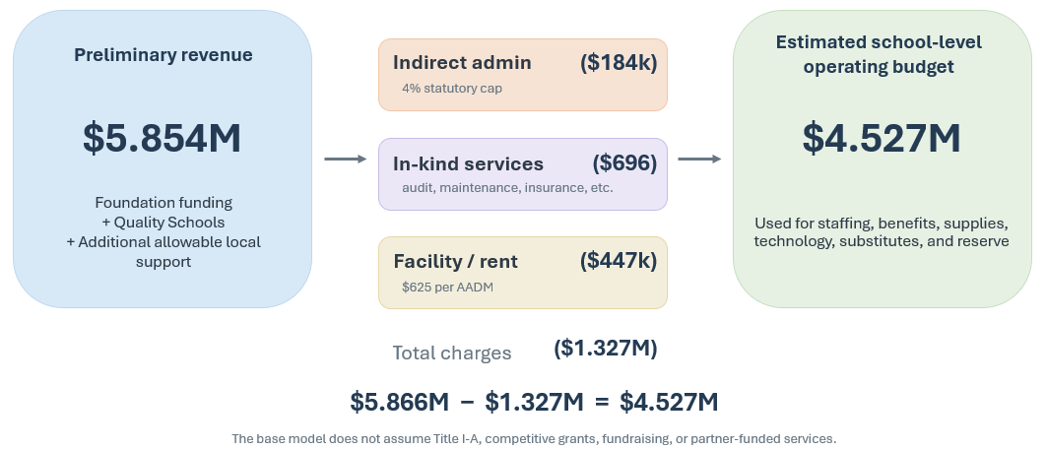
The preliminary school-level expenditure plan is shown below in Table I-4 and Figure I-2.
Table I-4: Preliminary School-Level Expenditure Plan
Expenditure Category | FY28 Planning Budget | % of Net Budget
Salaries / Wages (includes substitutes) | $2,524,708.71 | 55.8%
Health Benefits | $1,150,950.19 | 25.4%
Other Employer Payroll Costs | $452,290.63 | 10.0%
Teacher Discretionary Funding | $5,637.50 | 0.1%
Special Education Support Services (4220) | $221,218.00 | 4.9%
Staff Travel | $2,913.00 | 0.1%
Direct Utilities | $133,223.00 | 2.9%
Purchased Services | $3,731.50 | 0.1%
Supplies / Materials | $23,023.00 | 0.5%
Dues / Fees / Other | $787.00 | 0.0%
Equipment / Technology | $5,000.00 | 0.1%
Total Projected Expenditures | $4,523,483 | 99.9%
Net Operating Funds | $4,725,144 | 100%
Source: Appendix I Budget Workbook, “Budget” & “Staffing” tabs.

Figure I-2: Operating Budget Breakdown
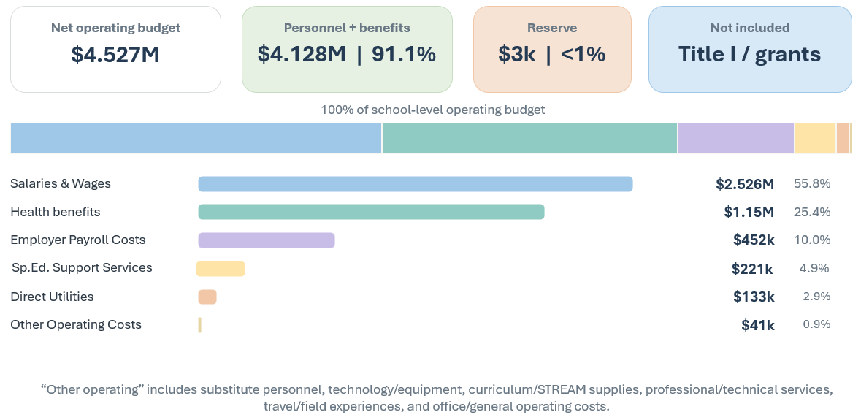
Source: Appendix I FY28 Budget Workbook

Special Education Support Services (Function 4220) Planning Assumption
The preliminary model includes a $221,218 planning allowance for district-provided Special Education Support Services - Student (Function 4220). This amount is based on Soldotna Elementary's FY26 Function 4220 allocation and is used as a provisional FY28 proxy because KPBSD has not yet provided a charter-specific FY28 related-services allocation. KPBSD defines Function 4220 to include IEP-related guidance, health services, social work, psychological services, speech pathology, audiology, physical therapy, and associated salaries, benefits, supplies, equipment, and travel. The actual FY28 amount will depend on enrolled students, IEP service requirements, district staffing assignments, and KPBSD's allocation methodology and will be updated in coordination with KPBSD Finance and Pupil Services.

Staffing Plan
The preliminary budget supports approximately 33.72 FTE, consisting of 21.50 certificated FTE and 12.22 classified FTE. These totals exclude related-service personnel funded within the Function 4220 allowance.
The FY26 Final Budget identifies 34.96 FTE at Soldotna Elementary, including 22.05 certificated and 12.91 non-certificated FTE. The revised FY28 direct staffing plan includes 12.0 classroom teacher FTE, 3.0 specialist FTE for Music, Science, and Physical Education, 0.50 reading/intervention FTE, 3.0 resource teacher FTE, and 2.0 intensive teacher FTE. Function 4220 separately funds related services in the proposed model, so direct FTE totals are not a complete count of all personnel serving students.
At 290 students, 12 classroom teachers equate to an average of approximately 24.2 students per classroom teacher. The workbook scales the FY27 grade distribution to assumed FY28 grade counts. The 12-classroom option assumes some combined-grade classes and requires an approved schedule.
The three-specialist model is an intentional component of the instructional program. KPBSD's FY27 certified staffing formula provides 2.0 specialist FTE at 270–345 students; this plan adds one specialist FTE to support dedicated Science instruction alongside Music and Physical Education. The rotation also supports predictable classroom-teacher planning, grade-level collaboration, data review, curriculum mapping, and professional learning, subject to the final schedule and applicable negotiated agreements.
The FY27 certified staffing formula for elementary schools with at least 250 students uses allocation ratios of 1:22.5 in kindergarten, 1:24.5 in grades 1–3, and 1:26.5 in grades 4–6. Applying those ratios to the assumed grade counts produces 11.59 unrounded classroom FTE, a District-rounded allocation of 11.5 FTE, and a whole-teacher planning option of 12. These ratios allocate staffing; the source does not establish absolute class-size caps. Use of the FY27 formulas for FY28 remains a planning assumption.
Support staffing includes 7.33 special education aide FTE, 0.44 library aide FTE, 0.88 nurse FTE, 1.05 office-support FTE, and 2.51 custodial FTE. Office and custodial costs use the unrounded FY26 published formulas at 290 students and the existing 54,177-square-foot building. Building assignment, shared-staff cost allocation, District rounding, and student service coverage will be updated when location and potential facility sharing is confirmed. The same goes for the school nurse, as the district provided number of 0.88 figure referred to contracted-service equivalents and does not establish a nursing allocation. Where funding and staffing permit, the school will seek improved class sizes and student support.

The preliminary charter-school staffing model is shown below in Table I-4 below.
Table I-5: Preliminary Staffing Model
Position / Function | FY28 Planning FTE
Principal | 1.00
Classroom Teachers – K–6 | 12.00
Specialized Teachers – Music, Science, Physical Education | 3.00
Reading / Intervention | 0.50
Special Education Teachers | 5.00
Certificated Total | 22.50
Special Education Aides | 7.33
Library / Instructional Aide | 0.44
Nurse | 0.69
Administrative / Secretarial Support | 1.05
Custodians | 2.51
Classified Total | 12.22
Total Staffing | 33.72

Compensation and Benefit Assumptions
Salary and benefit costs use the District Finance estimates retained in the budget workbook. Their FY28 applicability and employee-level salary placements remain subject to confirmation.
The model uses an annual teacher salary of $87,307, a principal salary of $124,910, and blended classified wages of $48,286 per FTE. These are District average-cost planning inputs rather than position-specific figures.
Actual salary expenditures will reflect each employee's approved position, experience, education, classification, work calendar, and salary placement.
Health benefits are modeled at $34,133.61 per FTE, based on the District estimate of $32,508.20 increased by 5 percent. Applying health costs to fractional FTE is a planning proxy; final costs depend on eligible employee headcount and coverage.
Other employer costs are modeled using TRS at 12.56% for certificated staff, PERS at 22% for classified staff, Social Security at 6.2% for classified staff and substitutes, Medicare at 1.45%, life insurance at 0.15%, and unemployment at 0.15%. The workbook applies those rates by employee group, rather than using the prior blanket benefit percentage. Substitute wages are $20,000, with $1,590 in employer payroll costs.
Direct personnel costs total $4,127,949.52: $2,524,708.71 in salaries and wages, $1,150,950.19 in health benefits, and $452,290.63 in other employer payroll costs. Totals use the workbook's unrounded calculations; displayed components are rounded to cents. Final District rates and employee-level costs will replace these estimates.

Title I and Other Supplemental Funding Are Not Included in the Base Budget
The $4.529 million operating budget does not include Title I-A revenue.
Soldotna Elementary has historically received Title I-funded staffing and services; however, recent Alaska DEED report cards have not identified the school as a Title I school. Accordingly, the financial model conservatively includes $0 in Title I-A revenue until KPBSD Federal Programs confirms the school's FY28 eligibility, program model, and school-level allocation.
Under Alaska DEED guidance, Title I-A eligibility and school allocations depend on poverty measures, District ranking and serving rules, and the amount of available Title I funding. Eligibility therefore does not itself establish a particular school-level allocation.
If Title I or another attributable federal allocation is ultimately available, those resources could provide additional capacity for eligible academic intervention, extended learning, family engagement, or other allowable activities. They should be treated as supplemental resources rather than assumed base revenue until KPBSD identifies an actual allocation.
The budget likewise does not assume competitive grants, philanthropic contributions, fundraising, or partner support.
Potential future funding opportunities may include federal or state grants, local grants, community partnerships, and programs supporting extended learning. For example, Alaska's 21st Century Community Learning Centers program provides competitive federal grants for expanded learning and enrichment outside regular school hours. DEED's FY27 competition made approximately $3.9 million available statewide, with awards potentially continuing for up to five years subject to continued funding and performance. A prior Alaska 21st CCLC award to the Boys & Girls Clubs of the Kenai Peninsula served a KPBSD elementary school, demonstrating a local precedent for district/community partnership funding.
No such grant funding is included in the base FY28 budget.

Student Nutrition / Food Services — KPBSD Allocation Pending
Soldotna Elementary Charter School intends to continue participating in KPBSD Student Nutrition Services, including breakfast and lunch service. KPBSD accounts for school meal operations through its separate Food Service special-revenue fund, which is supported primarily by federal school-meal reimbursements, student meal sales, and USDA assistance. KPBSD also identifies food services as a District service for which costs may be assigned to charter-school budgets.

Continued Scenario Planning and Potential Program Enhancements
The APC and school administration will continue evaluating alternative staffing and program scenarios as enrollment, funding, and student needs become clearer.

Potential enhancements may be considered if additional funding, grants, partnerships, or operating capacity become available. No enhancement costs or unawarded funding are included in the revised base operating plan.
Any proposed enhancement will be costed separately and reviewed against the final operating budget before a commitment is made.
Potential priorities to be explored include after-school tutoring and enrichment, extracurricular clubs and academic teams, expanded STREAM activities, counseling and social-emotional support, community-based student-support partnerships, and additional intervention or specialist staffing.
With a projected surplus of approximately $3,661, the base plan has limited capacity for additional recurring costs. Enhancements depend on the final allocation, actual staffing costs, confirmed supplemental funding, grants, partnerships, and APC priorities. Recurring positions will not rely on the assumption that short-term or competitive grant revenue will continue indefinitely.

Annual Budget Development and Financial Oversight
The preliminary FY28 model is intended to demonstrate that the proposed school can operate within a reasonable projected allocation using staffing levels broadly comparable to the existing Soldotna Elementary operation.
Before each school year, the administrator and APC will work with KPBSD Finance to update:
- actual and projected enrollment;
- state foundation funding;
- local contribution;
- indirect charges;
- facility and in-kind costs;
- employee salary placement;
- employee benefit rates;
- special education and other student-support requirements;
- available federal or grant funding; and
- other operating assumptions.
The APC will review budget-to-actual financial information throughout the year and make adjustments as necessary to maintain a balanced and sustainable program.
If actual revenue is lower than projected, priority will be given to maintaining core classroom instruction and legally required services before discretionary expenditures or enhancements. If revenue exceeds projections or supplemental resources become available, the APC may consider investments in staffing, class size, student support, STREAM programming, extracurricular and after-school programming, curriculum, technology, professional development, or reserves.

Budget Workbook & Supporting Financial Exhibits
The detailed Appendix I Soldotna Elementary Charter School FY28 Budget Workbook is incorporated as the supporting financial model for this appendix, and attached here. However, screenshots of the model are also provided below.
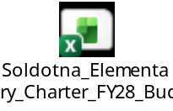

Summary
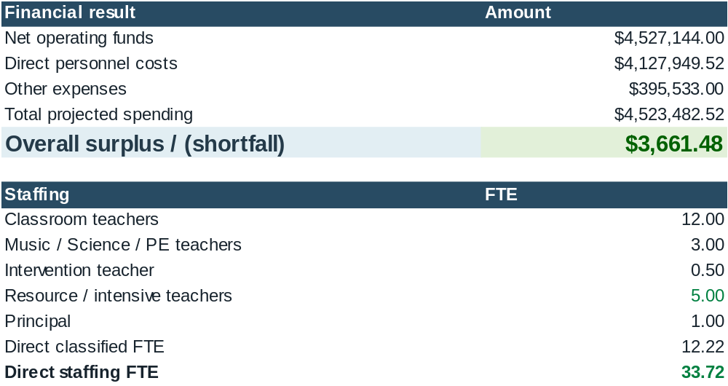
Budget
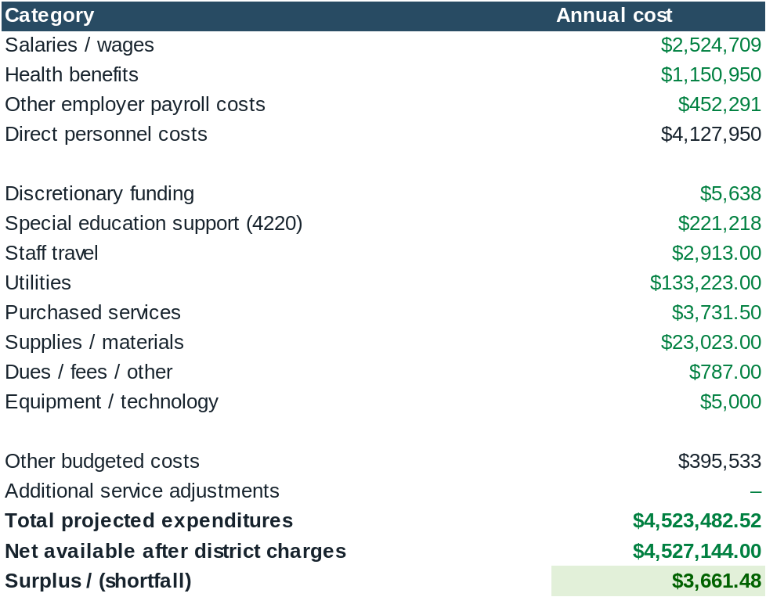
Staffing
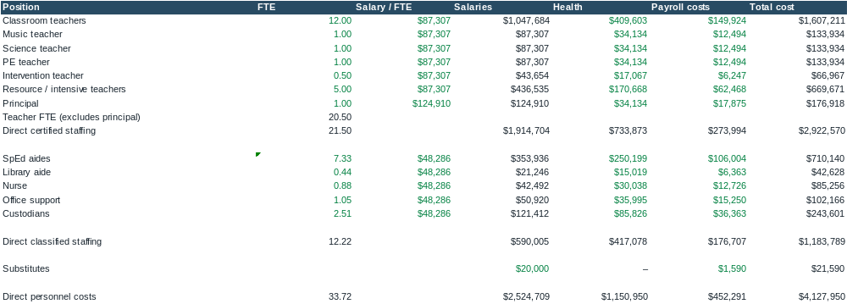

KPBSD FY26 Final Budget, Function 4220, printed p. 60; function definition printed p. 238.

